Michael Martin
Biology/Environmental Science
Oxford College of Emory University
ENVS 131 – Introduction to Environmental Studies

Course Summary

I have taught ENVS 131 with a focus on the ‘natural world’ and its inevitable degradation in the face of human development. My time in the Piedmont Project has provided the powerful lens of sustainability that will allow my students and I to examine how human actions can be both the cause and solution to many environmental issues. Additionally, the Piedmont Project expanded my view of sustainability from being centered largely on limiting resource use, to a more complete picture that includes a healthy environment, a growing economy, and an equitable distribution of both.

My course now begins with a focus on Earth Systems by working from the inside of the Earth to the outside discussing geologic processes, aquatic environments, terrestrial biomes, climate, and biodiversity among other topics. The majority of the course is then dedicated to understanding human impacts on these natural systems. One dichotomy I hope to establish as I transition from Earth Systems to The Human Species is that natural systems are often characterized by cycles (i.e., food webs, nutrient cycles) while human systems are often not (i.e., industrial manufacturing and consumption). I hope to encourage my students to think about how policy or personal decisions can help ‘close the loop’ on some of these human processes.

The remainder of the course will examine environmental issues starting with providing water, food, and shelter for the growing human population, and then move into understanding our environmental impact as we try to meet our material needs beyond the ‘basics.’ Each issue will be described using textbook material and supplemental information from UN and EPA reports. Each environmental issue will be accompanied by a case study (i.e., the 2007 Atlanta drought). Students will be assigned follow-up reading to discuss in the next class period. Students will answer questions on the readings outside of class to help them prepare for in-class discussions (called ‘Reflections’ on the syllabus). These questions will focus largely on understanding the issue outlined in the case study, how unsustainable practices contributed to the situation, and how sustainable practices could resolve the current situation or avoid future crises. Students should be able to articulate how personal decisions as well as societal decisions based in policy could be applied to each case study. This course structure should highlight the necessity of sustainable practices for students and allow them to define their own sustainable priorities and lifestyle.

ENVS 131 – Introduction to Environmental Studies
[Oxford College of Emory University - Fall 2018]
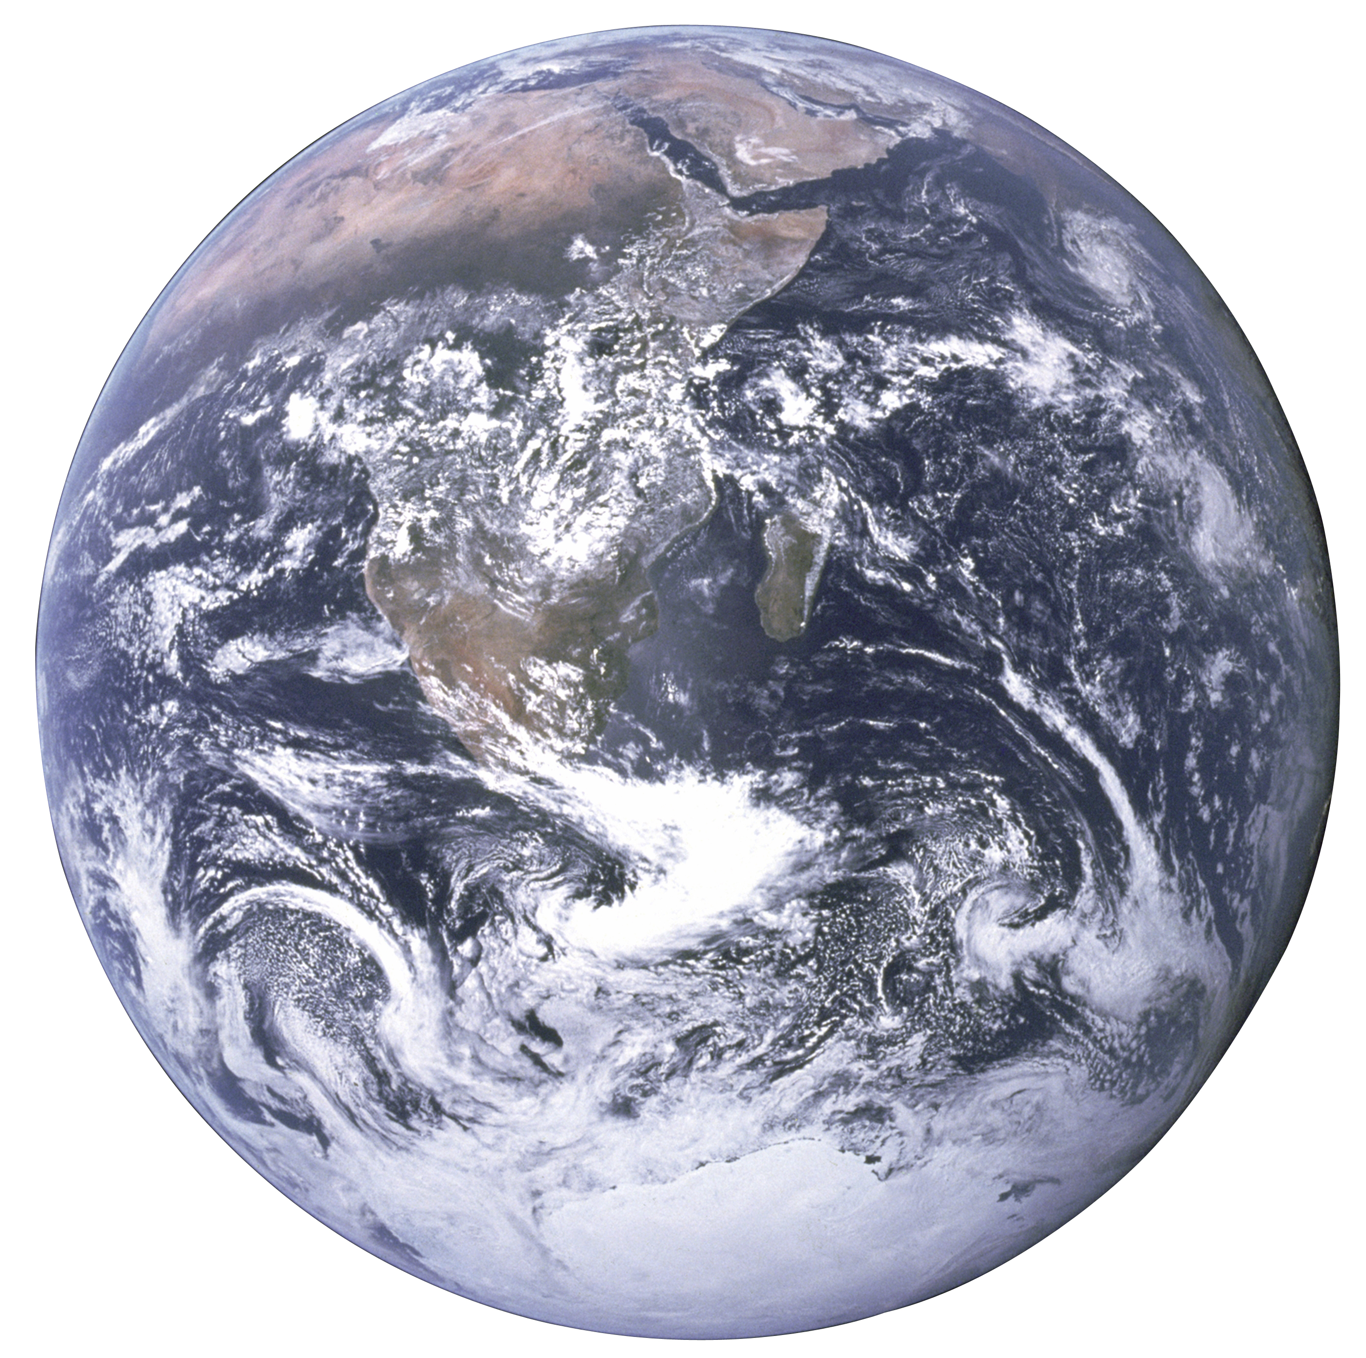
Lecture: T and Th 10:00-11:15am, OSB 101
Lab: W 2:00-5:00pm, OSB 201

Instructor: Dr. Michael Martin, mmart50@emory.edu, OSB 308
Office Hours: Friday 10:00-11:00am or by appointment

Course Objectives:
- Discuss the major themes in environmental science
- Understand the natural world, our impact on its processes, and how we can mitigate those impacts
- Practice observing the environment, generating questions, and evaluating evidence (you will be a scientist)
- Develop field techniques and analyze real-world data (you will be outside)
- Evaluate ongoing environmental issues through the lens of sustainability

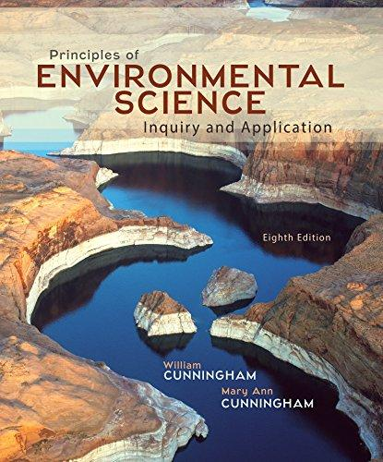
Required Text:
Principles of Environmental Science: Inquiry and Application
Cunningham & Cunningham
8th Edition
ISBN: 978-0-07-803607-1

Reading:
Class time will often involve discussions led by you. In order to be a full participant in class, you will need to come to class having read the assigned material.

Grades:

Exams (3 @ 100 points) 300
Final Exam 100
Reflections (7 @ 15 points) 105
Issue Debate Project 80
Lab Assignments (5 @ 15 points) 75
Lab Exams (2 @ 75 points) 150
TOTAL 810

Classroom philosophy:

I view the classroom as a learning community – we will all take part in each other’s learning experience. To this end I will work hard to provide opportunities for you all to interact with each other through team-based discussions, reflections, and activities. I will also assign individual class work – view these assignments as a dialogue between you and I about your progress in the class and your understanding of the course material – don’t just look at the grade, read my comments as well. We can (and should) continue this dialogue in person. My door won’t always be open but I will always find time to meet with you 1 on 1.

In addition to mastering course content, I’d like all of you to finish the course having gained critical thinking practice and honed your ability to ask and answer your own questions.

Attendance:

Attendance is mandatory – and really the only way you’ll get the most out of this course. ENVS 131 follows the attendance policy laid out by the Biology Department, which is detailed on the attached handout.

Class Structure:

After we’ve explored EARTH SYSTEMS in UNIT 2, we will address the impact our society has on these systems. We will explore various environmental issues through global, regional, and local perspectives. Each class period will end in a case study that exemplifies the issue. Our job as a class will be to follow up on this case study through out-of-class readings and classroom discussion in the next class period to understand the factors that initiated, prolonged/maintained, and resolved the issue at hand. Our framework for understanding these case studies will rely on the ‘sustainability triangle.’
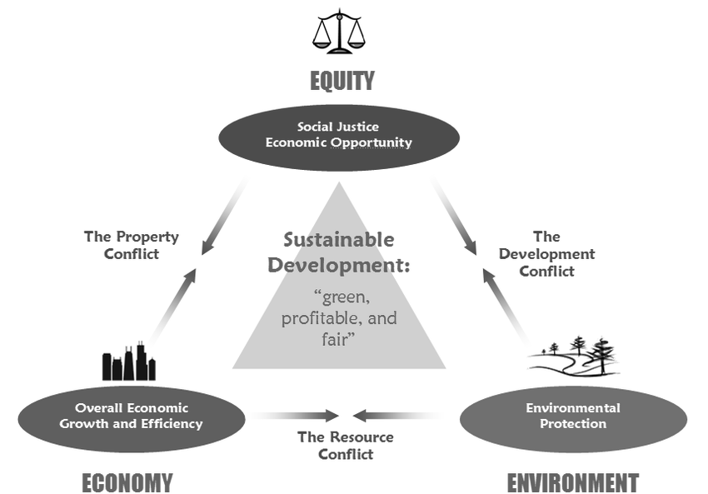

In-class policies:

- Laptops are more often a distraction than a learning aid – if you feel your learning is best accomplished with a laptop please come talk to me
- Cell phones should not be visible or audible in class
- Academic dishonesty will not be tolerated and handled according to the Oxford College Honor Code (http://oxford.emory.edu/catalog/regulations/honor-code.html)

- NEVER hesitate to ask a question in or out of class

Accommodations:

If you have Academic Accommodations please let me know as soon as possible so we can communicate with the Office of Accessibility Services (https://inside.oxford.emory.edu/life-at-oxford/accessibility-services/).

Student support:

The one stop shop for student support is the Advising Support Center run by Lauren Braun, Seney Hall 103.

Class # | Date | Lecture | Reading
UNIT 1 – INTRODUCTION TO ENVIRONMENTAL SCIENCE
1 | 30-Aug | Welcome and Course Overview | --
2 | 4-Sep | Environmental Science | 3-14; 21-24
3 | 6-Sep | The Scientific Method | 14-21
UNIT 2 – EARTH SYSTEMS
4 | 11-Sep | Plate Tectonics and The Rock Cycle | 283-287
5 | 13-Sep | Soils and Nutrient Cycles | 41-47; 163-166
6 | 18-Sep | Water | 105-109; 252-255
7 | 20-Sep | Atmosphere, Climate, and Weather | 209-213
8 | 25-Sep | Biomes | 98-104
9 | 27-Sep | Ecology | 28-41; 64-74
10 | 2-Oct | Evolution and Biodiversity | 52-64; 110-112
11 | 4-Oct | EXAM 1 on UNITS 1 and 2 | --
FALL BREAK October 8th and 9th
UNIT 3 – THE HUMAN SPECIES
12 | 11-Oct | Human Evolution and Sustainability | readings
13 | 10-Oct | Water Use with Case Study | 255-273; 278-279
14 | 16-Oct | Reflection | readings
15 | 18-Oct | Food and Agriculture with Case Study | 154-162; 166-178
16 | 23-Oct | Reflection | readings
17 | 25-Oct | Human Waste/Sanitation with Case Study | 273-277
18 | 30-Oct | Reflection | reflection
19 | 8-Nov | EXAM 2 on UNIT 3 | --
20 | 2-Nov | Urbanization with Case Study | 354-375
21 | 6-Nov | Reflection | readings
UNIT 4 – HUMAN CONSUMPTION
22 | 13-Nov | Energy Production with Case Study | 304-329
23 | 15-Nov | Reflection | readings
24 | 20-Nov | Municipal Solid Waste with Case Study | 333-350
THANKSGIVING BREAK November 22-24th
25 | 27-Nov | Reflection | readings
26 | 29-Nov | Climate Change with Case Study | 213-227
27 | 4-Dec | Reflection | readings
28 | 6-Dec | EXAM 3 on UNIT 4 | --
29 | 11-Dec | Course Wrap-up | --
FINAL | 14-Dec | FINAL EXAM (9:00am-12:00pm) | --

Laboratory philosophy:

Labs are meant to supplement our material in lecture – to give you an opportunity to apply your new knowledge. You will be working in teams. Most of our labs will take place outside – expect to be outside even if conditions are uncomfortable and dress appropriately (layers, rain jackets, etc.). Being in the field can also be uncertain – although our lab is scheduled to end at 5:00pm, keep in mind that traffic and other unforeseen events can delay that time and plan any meetings Wednesday evenings accordingly.

Just as assignments are meant to be a dialogue, our entire lab period is also meant for interactions – between you and your student-colleagues, between you and I, and between all of us and our environment. Take time to just sit and watch your surroundings.

Class # | Date | Lab Activity
1 | 5-Sep | Tree Identification
2 | 12-Sep | Soils
3 | 19-Sep | Wetland Delineation
4 | 26-Sep | Biodiversity
5 | 3-Oct | Secondary Succession
6 | 10-Oct | PRACTICAL EXAM 1
7 | 17-Oct | Surface Water I
8 | 24-Oct | Surface Water II
9 | 31-Oct | Surface Water III
10 | 7-Nov | Primary Succession I
11 | 14-Nov | Primary Succession II
THANKSGIVING BREAK November 21st
12 | 28-Nov | PRACTICAL EXAM 2
13 | 5-Dec | Issue Debate Presentations

